

***INSTITUTE OF INFORMATION TECHNOLOGY***

***JAHANGIRNAGAR UNIVERSITY***

**Number of Assignment :** 01

**Course Tittle :** Algorithm Analysis and Design

**Course Code :** ICT – 2201

**Submission Date :** 24/01/2022

**Submitted To Submitted By**

Dr. M. Abu Yousuf Md. Shakil Hossain

Professor Roll – 2023

IIT – JU 2nd year 2st Semester

IIT – JU

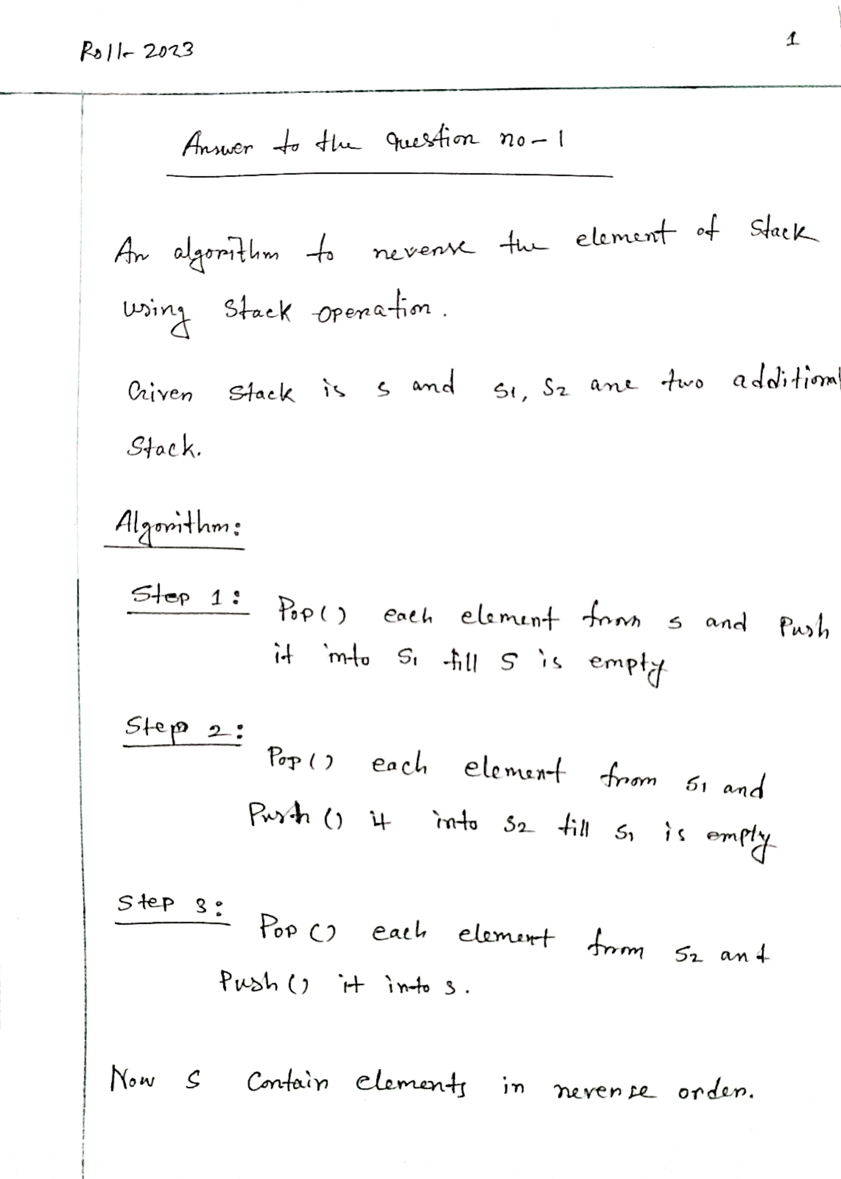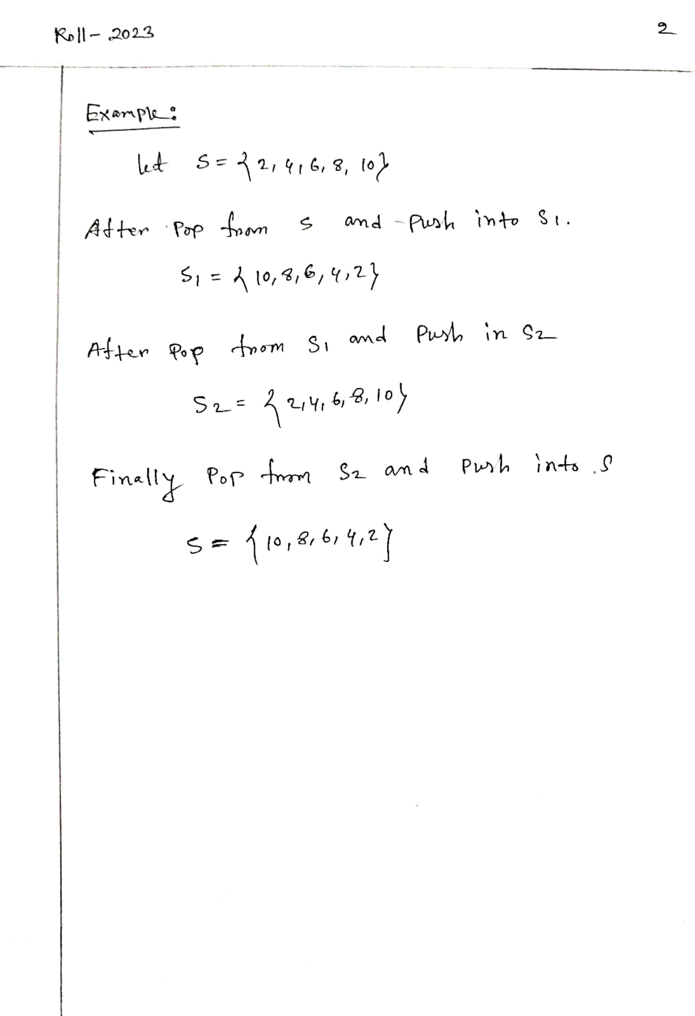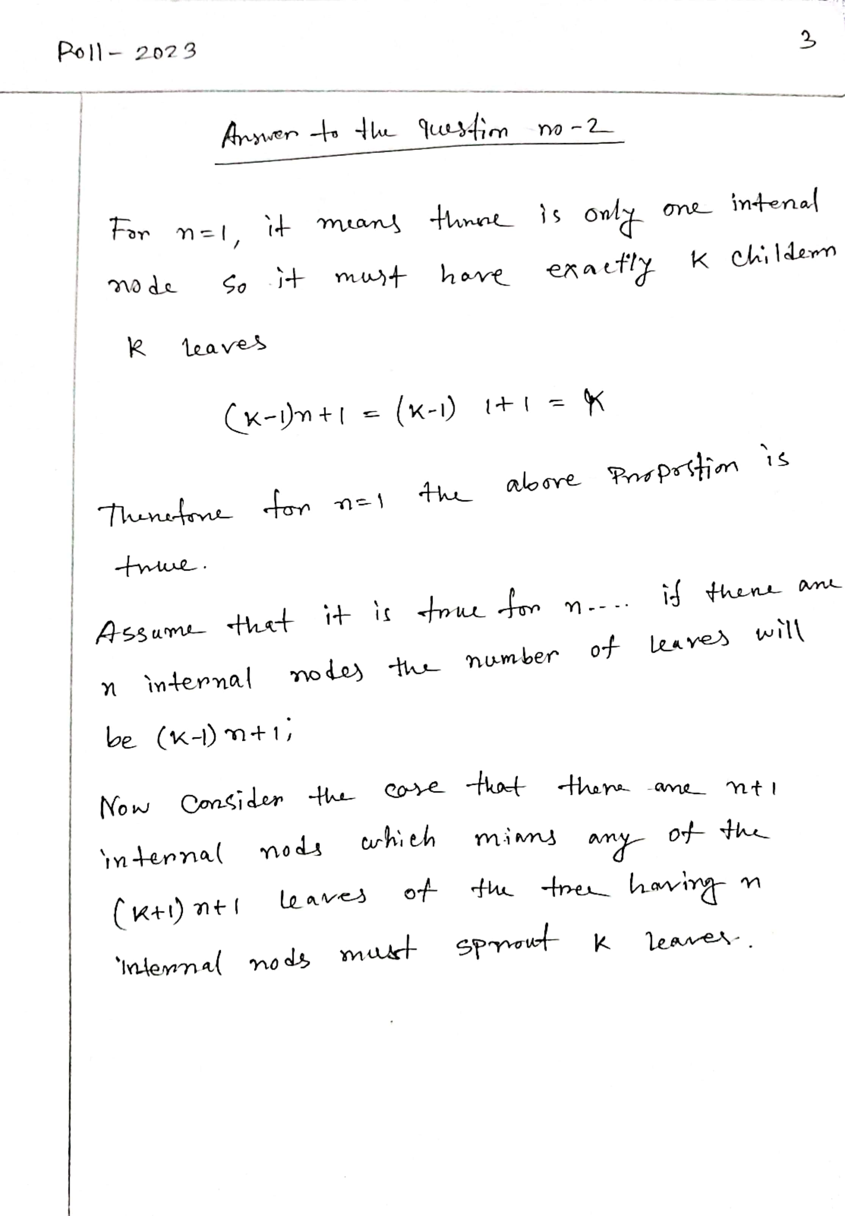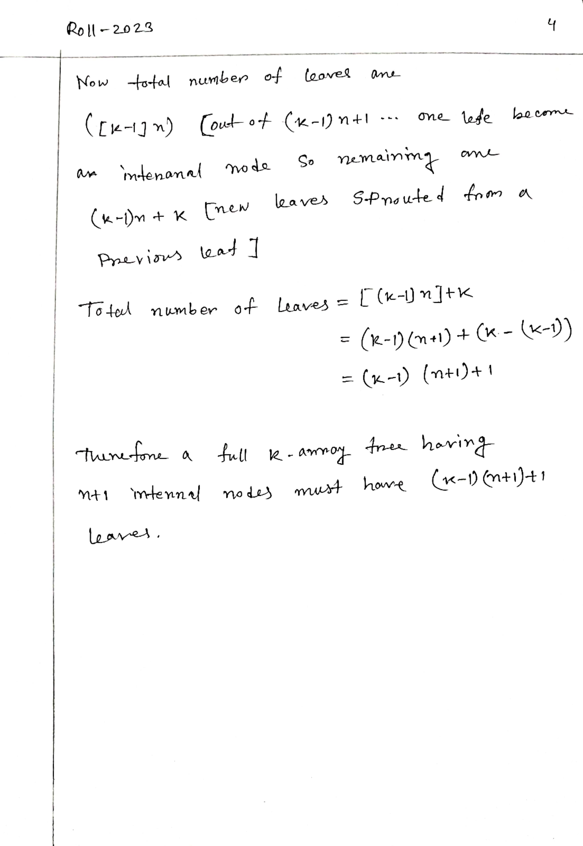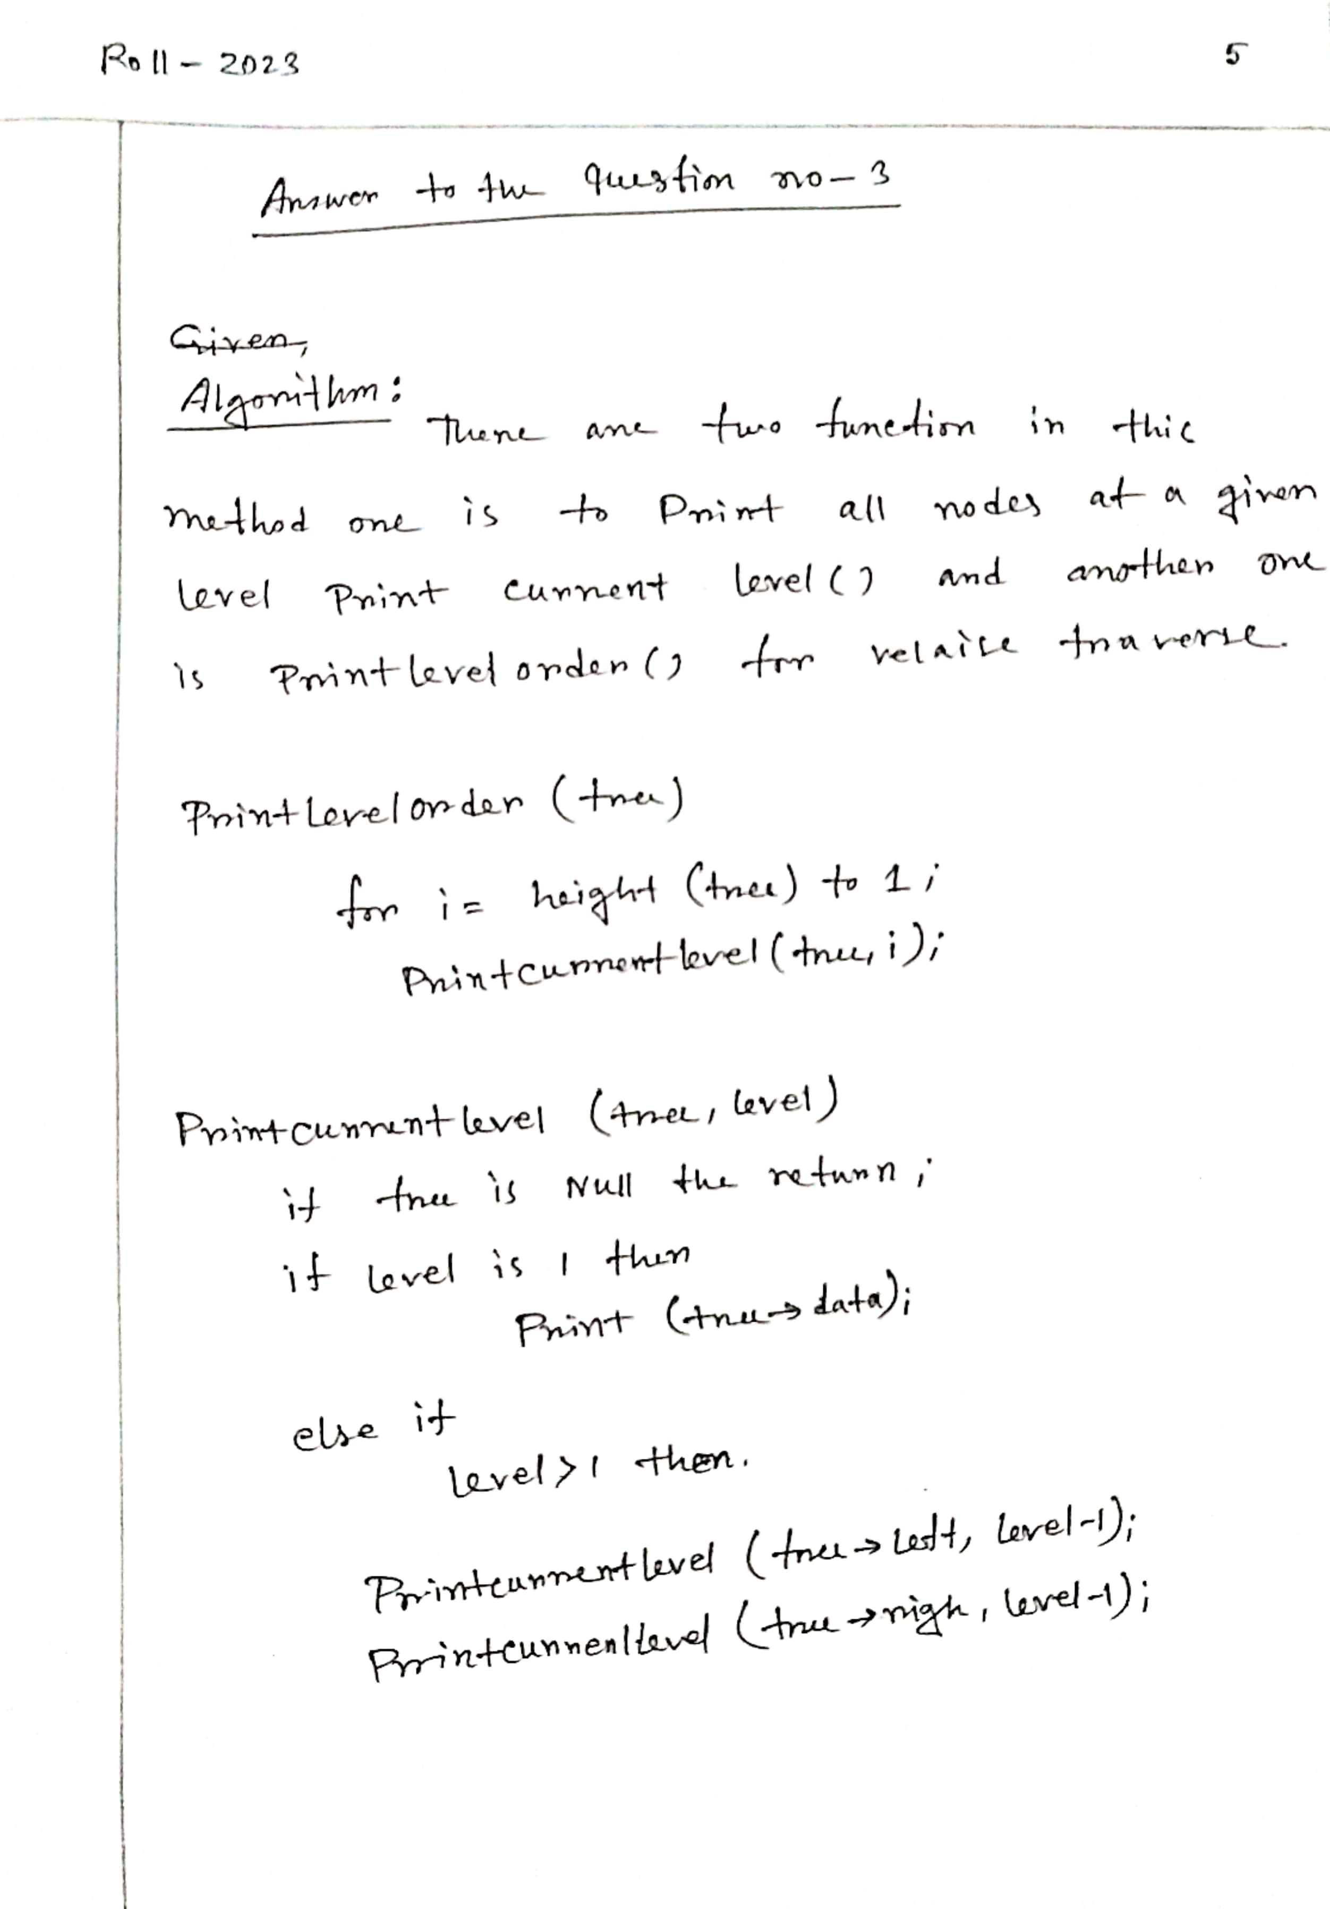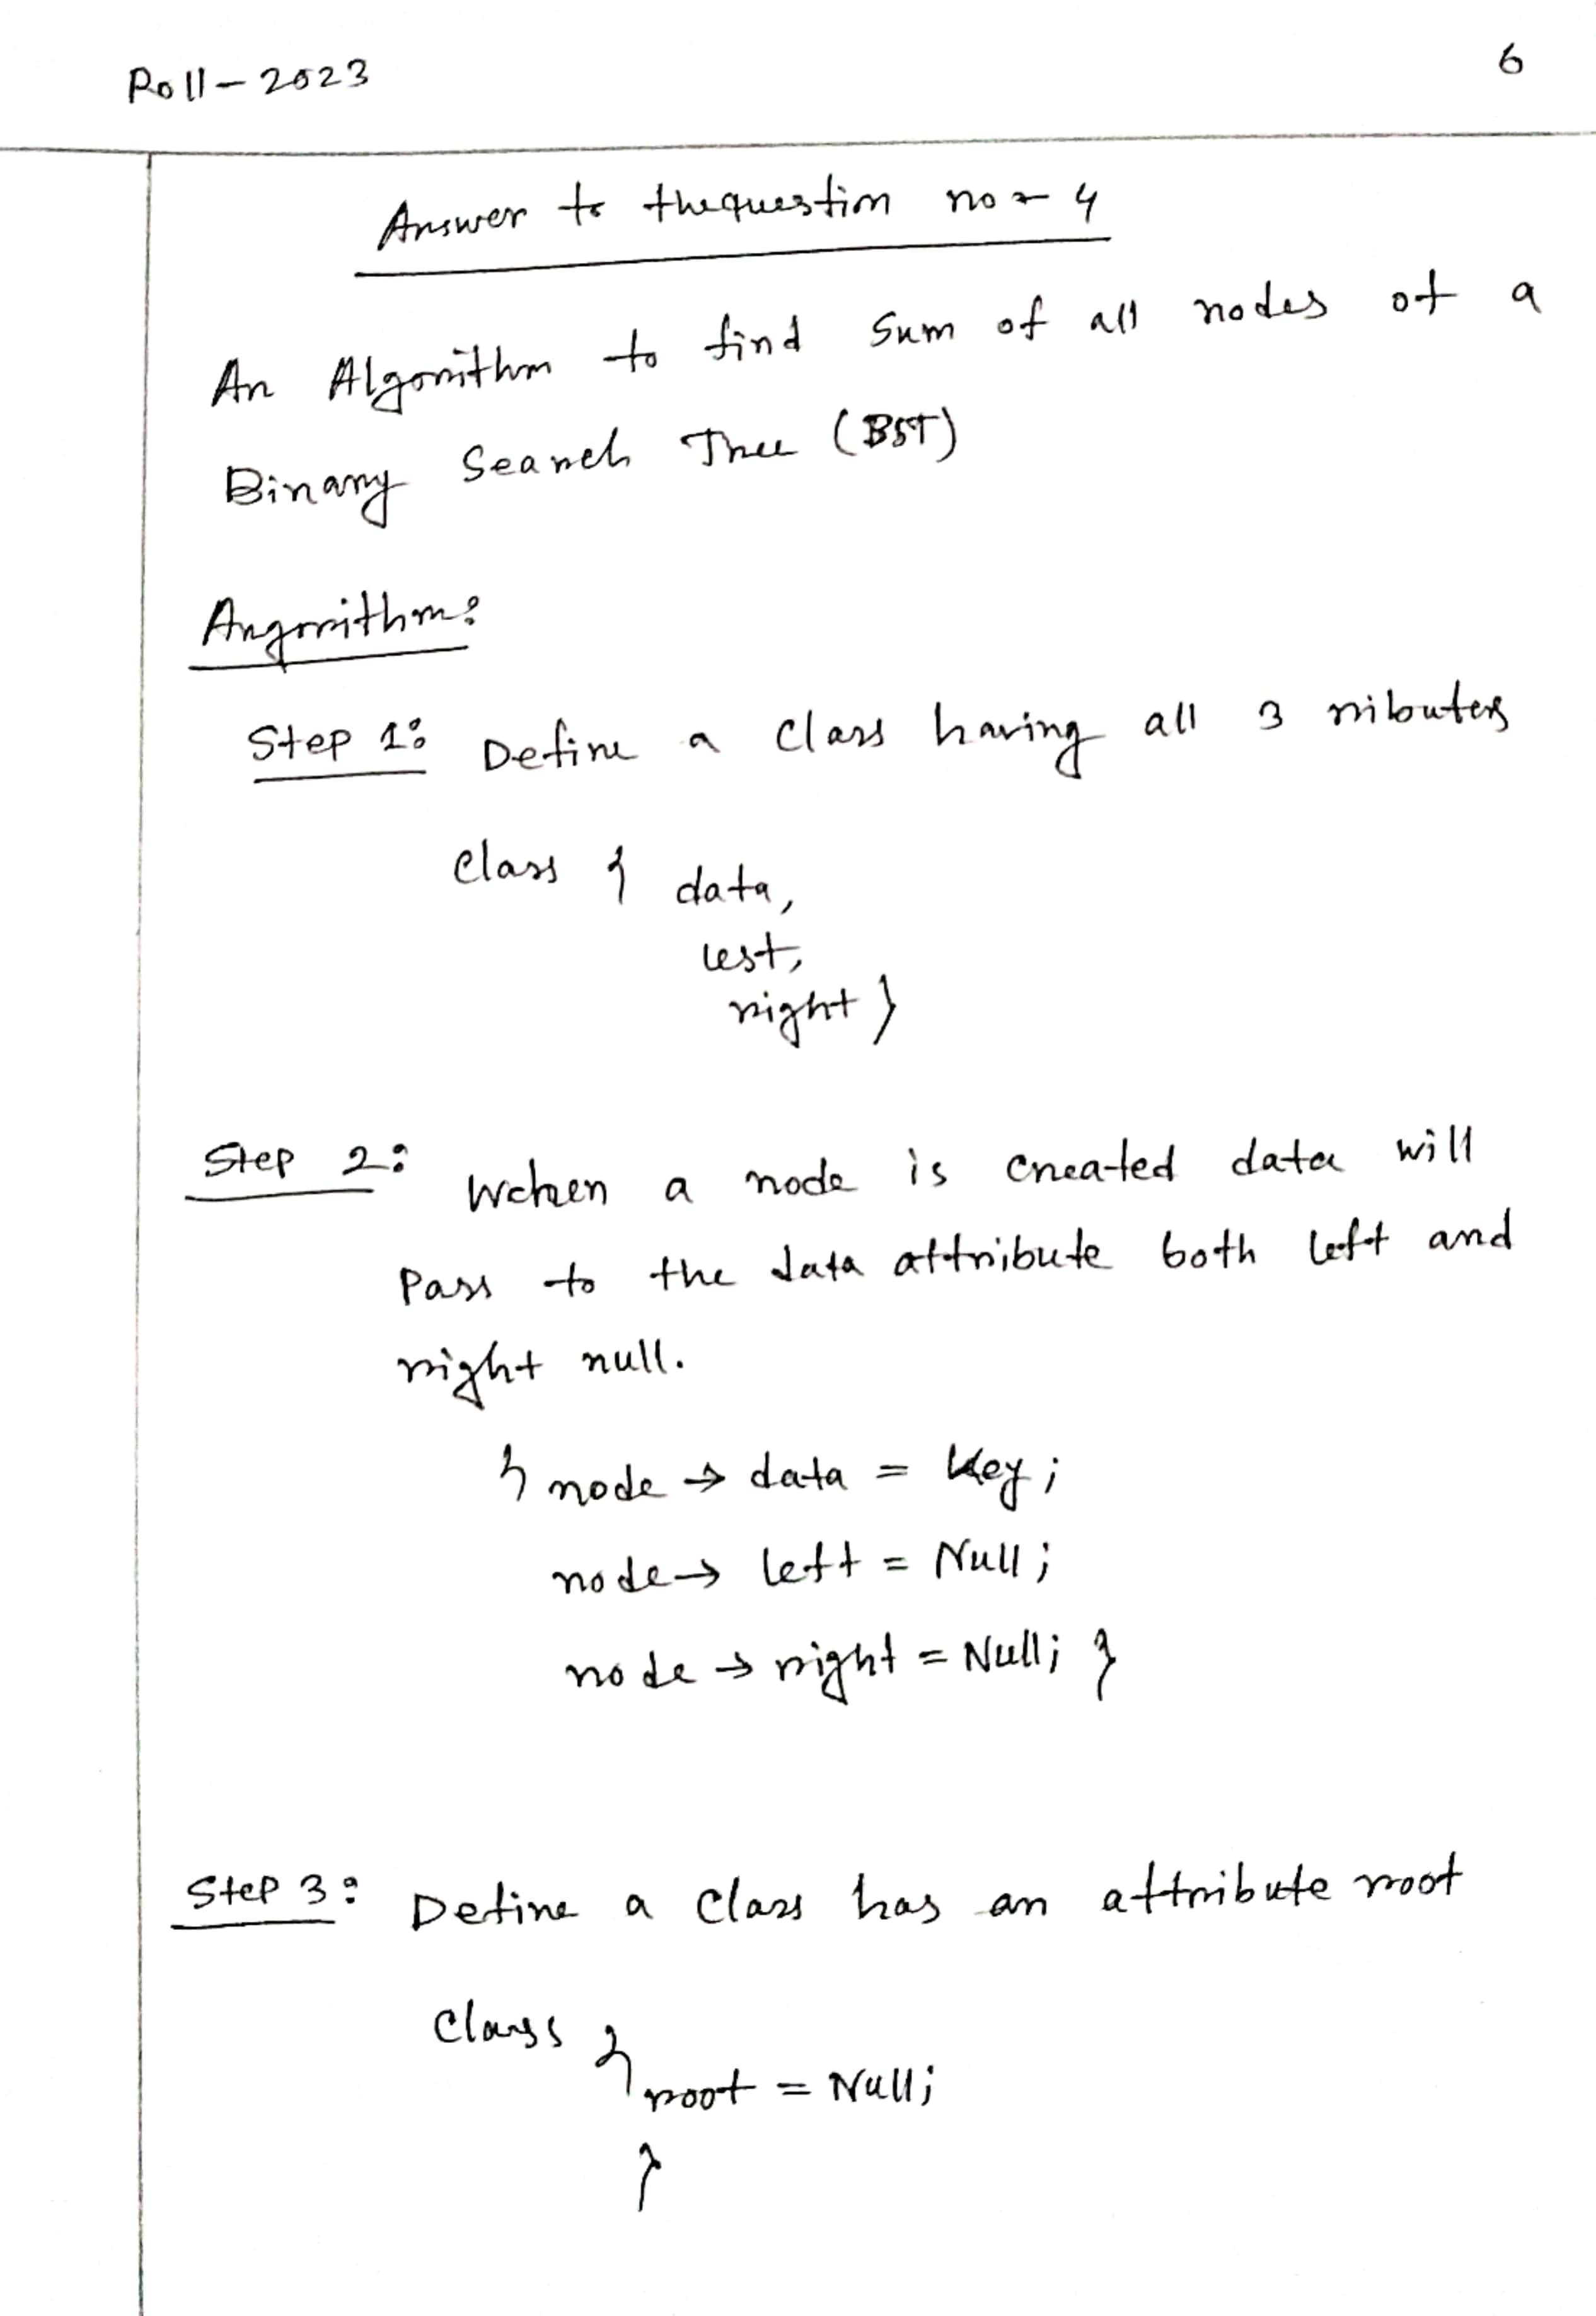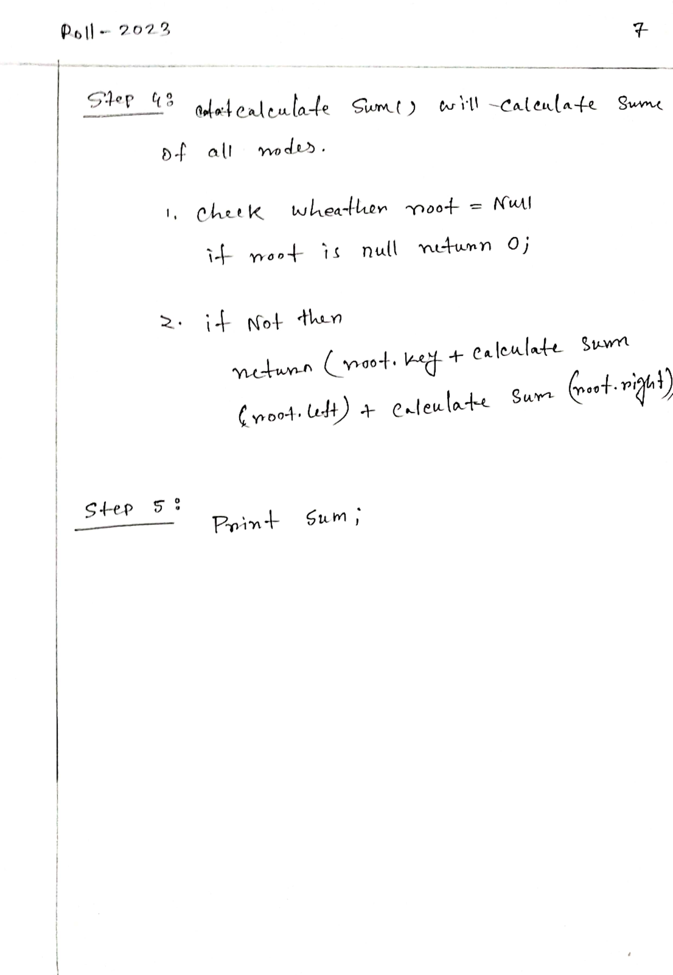

**THE END**